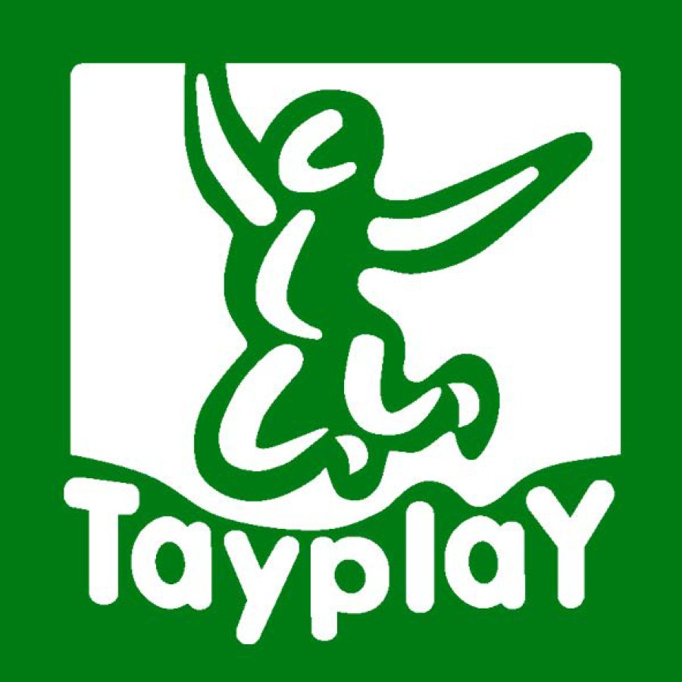
Supplier Code of Conduct
PlayPower achieves financial and commercial success by conducting its business based upon ethical values that promote respect and care for its employees, its customers, the children and people who enjoy its recreational products, and the communities it serves. PlayPower accepts and embraces its social responsibility to protect the environment, to govern itself as a good corporate citizen of the world, and to conduct its business ethically and free from corrupt practices, while always promoting and protecting human rights throughout the world. PlayPower expects its Suppliers and their facilities to comply with all applicable labor, employment, health and safety, environmental, and anti-corruption laws and regulations of the countries where they conduct business. At a minimum, Suppliers and their facilities are expected to meet the requirements set forth in this Supplier Code of Conduct. Adherence to these principles is mandatory for all Suppliers. By signing below and returning a copy to PlayPower, you acknowledge receipt of a copy of this Supplier Code of Conduct, and that you understand and will adhere to PlayPower’s requirements.

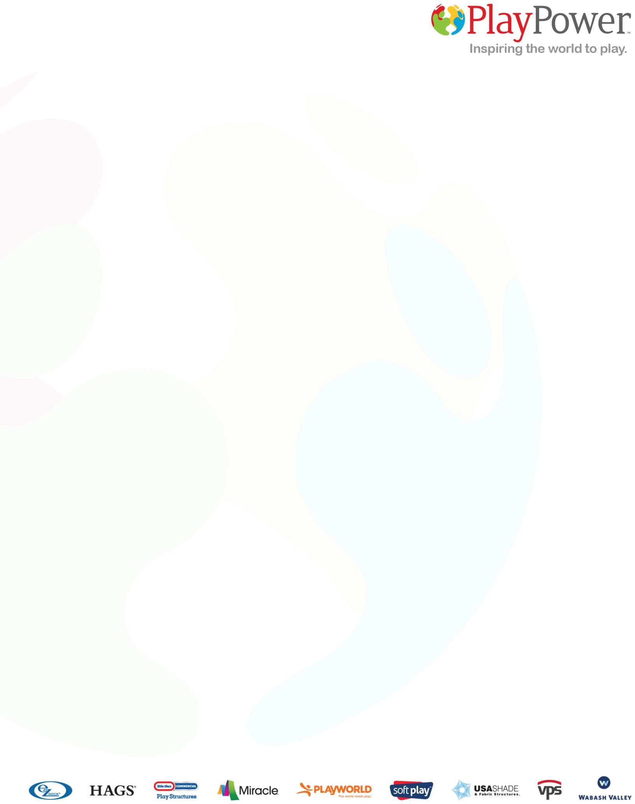
HUMAN RIGHTS
As a commitment to ethical business practices, social responsibility and good corporate citizenship, Supplier must acknowledge and respect the fundamental principles contained in the Universal Declaration of Human Rights and in the United Nations Global Compact's (UNGC) Ten Principles in the areas of human rights, labor, environment, and anti-corruption. In addition, Supplier shall uphold the following labor practices:

FAIR AND EQUITABLE WORKPLACE: Workers deserve a fair and ethical workplace environment and must be treated with the utmost dignity and respect. Accordingly, Supplier must treat its Workers with dignity and respect at all times, provide a mechanism for reporting human rights violations and where it is allowed by law, have a system that allows Workers to anonymously report concerns.
EMPLOYMENT STATUS: Supplier’s hiring practices must include
verification of Workers’ legal right to work in the country and ensure that all mandatory documents, including work permits, are timely obtained and available for inspection.
EMPLOYMENT PRACTICES: Supplier shall ensure that all work is voluntary. There shall be no trafficking of persons or use of any form of slave, forced or indentured labor. Involuntary labor includes the transportation, harboring, recruitment, transfer, receipt or employment of persons by means of threat, force, coercion, abduction, fraud or payments to any person having control over another person for the purpose of exploitation.
Supplier shall not withhold Workers’ original government-issued identification and travel documents.
ANTI-DISCRIMINATION AND FAIR TREATMENT: Supplier shall not
discriminate against any Worker on the basis of race, age, disability, ethnicity, gender, pregnancy, marital status, parental status, social status, national origin, political or union affiliation, religion, sexual orientation in hiring and other employment practices or any other characteristic protected by local law, as applicable. Supplier shall commit to providing a workplace free of physical, psychological, sexual or verbal abuse or other unlawful harassment. Threats or other forms of intimidation are prohibited.

UNDERAGE LABOR: Supplier may not employ persons who are below the applicable legal minimum age to work. Underage (child) is a person under the minimum employment age according to the laws of the facility’s country.
WAGES AND BENEFITS: Suppliers shall comply with applicable wage and hour labor laws and regulations governing Worker compensation and working hours. Workers with the same qualifications, skills, experience and performance shall receive equal pay for equal work in accordance with applicable labor laws.

WORKPLACE ENVIRONMENT
Supplier shall provide a healthy and safe work environment for its Workers. Supplier shall take proactive measures that support accident prevention and minimize health risk exposure. Supplier shall provide Workers with appropriate workplace health and safety training.

ENVIRONMENTAL MANAGEMENT
Supplier is expected to conduct its operations in a way that minimizes the impact on the environment, its customers, and workers. Supplier shall minimize use of hazardous substances through implementation of substitution or reduction methods and as to the extent applicable to its operations, shall make efforts to reduce energy, water, and natural resource consumption by implementing methods to conserve them and develop, implement and maintain environmentally responsible business practices.
BUSINESS INTEGRITY
COMPLIANCE WITH LAW: Suppliers’ business activities shall comply with applicable laws and regulations in the countries and jurisdictions in which they operate. This Code applies to activities in the locations where suppliers’ goods are produced, where any related services are performed, and where the goods enter the supply chain.
ANTI-BRIBERY: Suppliers shall not engage in any form of bribery, kickbacks, corruption, extortion or embezzlement. Suppliers shall not take any action that would violate, or cause PlayPower to violate, any applicable anti-bribery law or regulation, including the
U.S. Foreign Corrupt Practices Act.
BOOKS AND RECORDS: Suppliers shall maintain accurate and transparent books, records and accounts to demonstrate compliance with applicable laws and regulations and this Code.
CONFIDENTIALITY: Suppliers shall safeguard PlayPower information by keeping it secure, limiting access, and avoiding discussing or revealing such information in public places. These requirements extend even after the conclusion of a Supplier’s business relationship with PlayPower.
GRIEVANCE MECHANISM: Suppliers shall create internal programs for handling reports of workplace grievances, including anonymous reports.
WHISTLEBLOWER PROTECTION: Suppliers are responsible for prompt reporting of actual or suspected violations of applicable laws and regulations, and of this Code. This includes violations by any employee or agent acting on behalf of either the Supplier or PlayPower. Such programs shall protect worker whistleblower confidentiality and prohibit retaliation.

Prohibited Material List:

Tayplay produces products intended for use by children. Various local, international
and Tayplay’s environmental objectives prohibit the use of heavy metals, phthalates and other chemical compounds within our products.

Materials supplied to Tayplay shall not exceed the following chemical limits:

Lead (Pb) within substrate materials, excluding electronics, less than 100ppm

  - Lead (Pb) with paints or coatings less the 90ppm
  - Cadmium (Cd) less than 100ppm
  - Phthalates – any type less than 0.1% by weight individually or collectively

  - PVC less than 1ppm, excluding electronics

  - Electronics – all materials must comply with current RoHS requirements.

A

  - Neoprene less than 1ppm

TAYPLAY
DESCRIPTION: | Prohibited Material List
REVS & DATE:  A - Tayplay Revision | CREATED BY: | DATE CREATED:  16/01/19
 | SPECIFICATION NUMBER:  TAY0001 | REV: | A

ACKNOWLEDGMENT OF TERMS

Accepted and agreed to on behalf of ,
a supplier to PlayPower. I acknowledge that I am authorized to bind such company to the terms herein. Signature:
Print Name: Date: Title:
Phone Number: COMPANY ADDRESS:

COUNTRY:

Return this executed signature page to the PlayPower representative:
Tayplay Limited
Suite D, Riverview House Friarton Road
Perth PH2 8DF

